## Persuasive Message

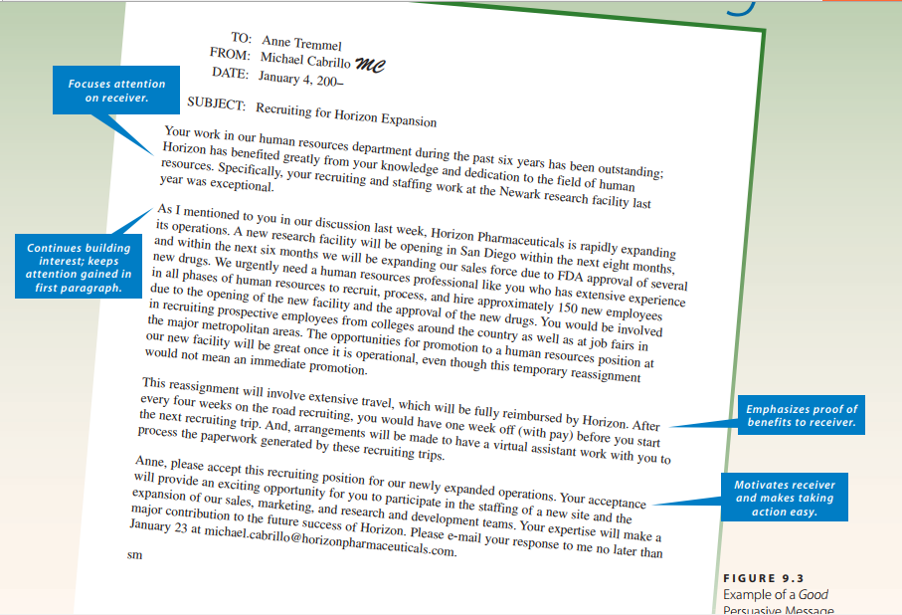

TO: Anne Tremmel

FROM: Michael Cabrillo MC

DATE: January 4, 200–

SUBJECT: Recruiting for Horizon Expansion

Your work in our human resources department during the past six years has been outstanding;

Horizon has benefited greatly from your knowledge and dedication to the field of human resources. Specifically, your recruiting and staffing work at the Newark research facility last year was exceptional.

As I mentioned to you in our discussion last week, Horizon Pharmaceuticals is rapidly expanding

its operations. A new research facility will be opening in San Diego within the next eight months,

and within the next six months we will be expanding our sales force due to FDA approval of several new drugs. We urgently need a human resources professional like you who has extensive experience in all phases of human resources to recruit, process, and hire approximately 150 new employees due to the opening of the new facility and the approval of the new drugs. You would be involved in recruiting prospective employees from colleges around the country as well as at job fairs in the major metropolitan areas. The opportunities for promotion to a human resources position at our new facility will be great once it is operational, even though this temporary reassignment would not mean an immediate promotion.

This reassignment will involve extensive travel, which will be fully reimbursed by Horizon. After

every four weeks on the road recruiting, you would have one week off (with pay) before you start the next recruiting trip. And, arrangements will be made to have a virtual assistant work with you to process the paperwork generated by these recruiting trips.

Anne, please accept this recruiting position for our newly expanded operations. Your acceptance

will provide an exciting opportunity for you to participate in the staffing of a new site and the

expansion of our sales, marketing, and research and development teams. Your expertise will make a major contribution to the future success of Horizon. Please e-mail your response to me no later than January 23 at michael.cabrillo@horizonpharmaceuticals.com.

## Persuasive Requests

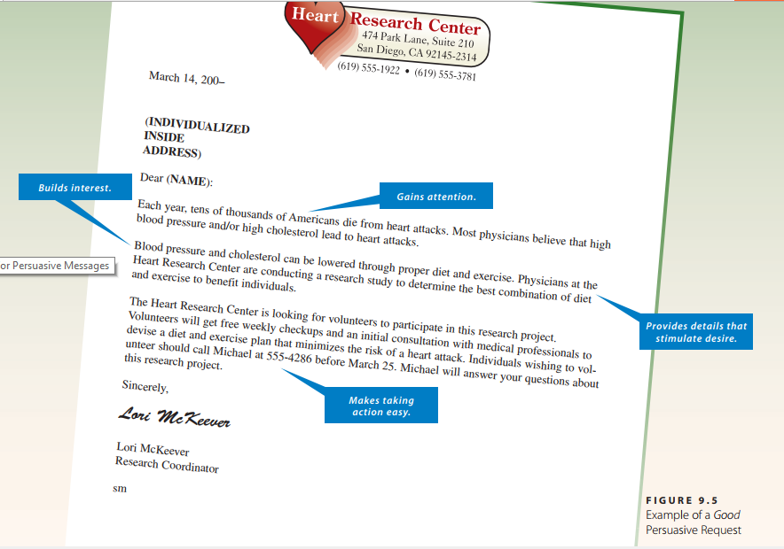

March 14, 200–

(INDIVIDUALIZED

INSIDE

ADDRESS)

Dear (NAME):

Each year, tens of thousands of Americans die from heart attacks. Most physicians believe that high blood pressure and/or high cholesterol lead to heart attacks.

Blood pressure and cholesterol can be lowered through proper diet and exercise. Physicians at the

Heart Research Center are conducting a research study to determine the best combination of diet and exercise to benefit individuals.

The Heart Research Center is looking for volunteers to participate in this research project.

Volunteers will get free weekly checkups and an initial consultation with medical professionals to devise a diet and exercise plan that minimizes the risk of a heart attack. Individuals wishing to volunteer should call Michael at 555-4286 before March 25. Michael will answer your questions about this research project.

Sincerely,

Lori McKeever

Lori McKeever

Research Coordinator

sm

## Recommendations

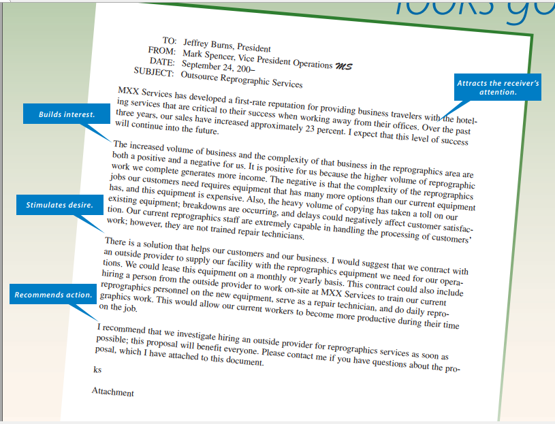

TO: Jeffrey Burns, President

FROM: Mark Spencer, Vice President Operations MS

DATE: September 24, 200–

SUBJECT: Outsource Reprographic Services

MXX Services has developed a first-rate reputation for providing business travelers with the hoteling services that are critical to their success when working away from their offices. Over the past three years, our sales have increased approximately 23 percent. I expect that this level of success will continue into the future.

The increased volume of business and the complexity of that business in the reprographics area are both a positive and a negative for us. It is positive for us because the higher volume of reprographic work we complete generates more income. The negative is that the complexity of the reprographics jobs our customers need requires equipment that has many more options than our current equipment has, and this equipment is expensive. Also, the heavy volume of copying has taken a toll on our existing equipment; breakdowns are occurring, and delays could negatively affect customer satisfaction. Our current reprographics staff are extremely capable in handling the processing of customers’ work; however, they are not trained repair technicians.

There is a solution that helps our customers and our business. I would suggest that we contract with an outside provider to supply our facility with the reprographics equipment we need for our operations. We could lease this equipment on a monthly or yearly basis. This contract could also include hiring a person from the outside provider to work on-site at MXX Services to train our current reprographics personnel on the new equipment, serve as a repair technician, and do daily reprographics work. This would allow our current workers to become more productive during their time on the job.

I recommend that we investigate hiring an outside provider for reprographics services as soon as possible; this proposal will benefit everyone. Please contact me if you have questions about the proposal, which I have attached to this document.

ks

Attachment

## Persuasive Claims

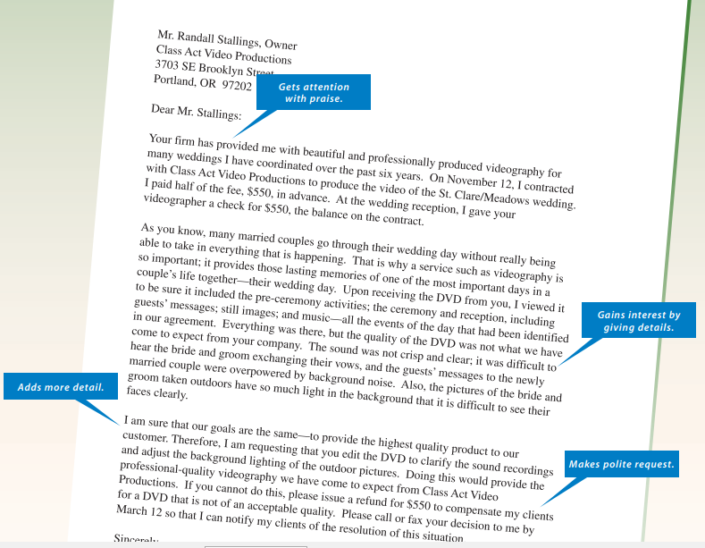

## Sales Message

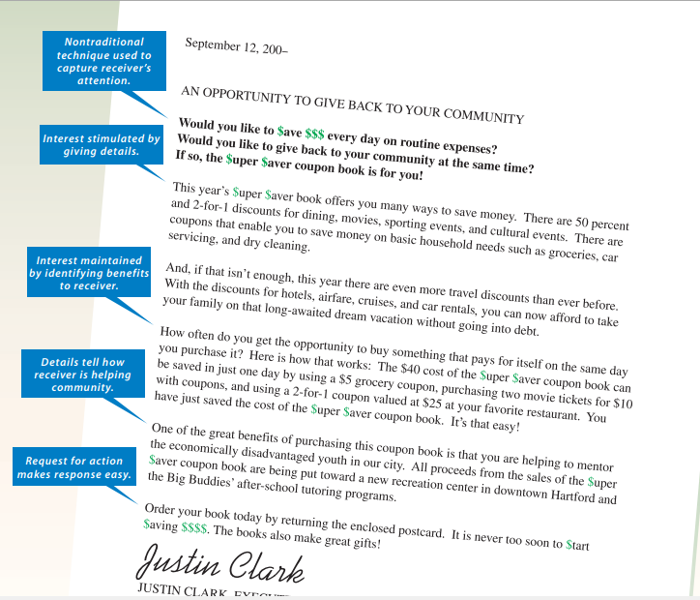

## Collections

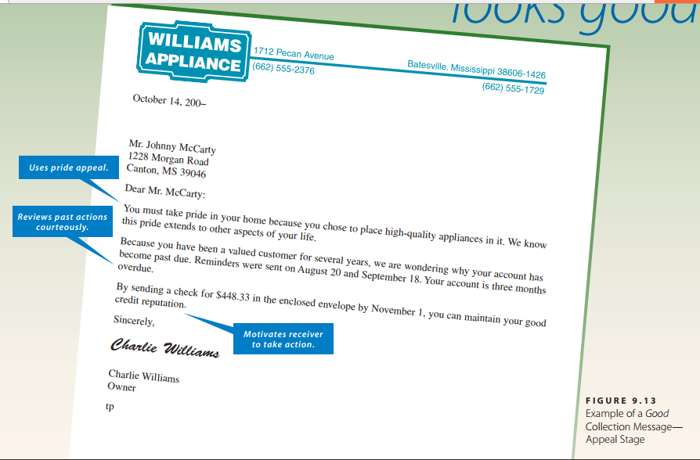

October 14, 200–

Mr. Johnny McCarty

1228 Morgan Road

Canton, MS 39046

Dear Mr. McCarty:

You must take pride in your home because you chose to place high-quality appliances in it. We know this pride extends to other aspects of your life.

Because you have been a valued customer for several years, we are wondering why your account has become past due. Reminders were sent on August 20 and September 18. Your account is three months overdue.

By sending a check for $448.33 in the enclosed envelope by November 1, you can maintain your good credit reputation.

Sincerely,

Charlie Williams

Charlie Williams

Owner

tp